**Exp 4 SMART PHONE CONTROLLED LIGHT SYSTEM**

**CIRCUIT DIAGRAM**

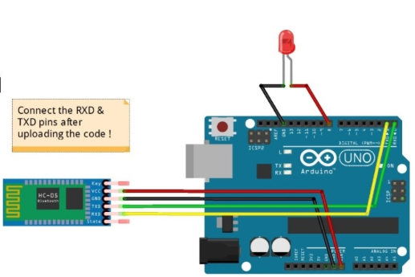

**THEORY**

**CONCEPT USED**

BLUETOOTH-HC05 used to transmit signal received from phone to arduino. Signal sharing between all this made this possible to control light through phone. A phone app is used for a complete connection between a phone and a Bluetooth module.

**LEARNING AND OBSERVATION**

HC 05/06 works on serial communication. The Android app is designed to send serial data to the Arduino Bluetooth module when a button is pressed on the app. The Arduino Bluetooth module at the other end receives the data and sends it to the Arduino through the TX pin of the Bluetooth module (connected to RX pin of Arduino). The code uploaded to the Arduino checks the received data and compares it. If the received data is 1, the LED turns ON. The LED turns OFF when the received data is 0.By opening the serial monitor received data can be watched.

**PROBLEM AND TROUBLESHOOTING**

While making the circuit, connection are needed to be maintained corrected. Problem which I faced while performing is that connection between module and mobile is done over wong network, when connecting phone with Bluetooth module using app right name must be selected.

**PRECAUTIONS**

1. Connections must be tight and correct.
2. Coding must be right.
3. Components used must be working properly.
4. It is better to keep the circuit switched off when it is not in use.
5. Module and phone must be on a same network

**LEARNING OUTCOMES**

Using such system can make it easier to control our home light system with just an app. With just one tap light can be on and with another light can be off.